CORE PHP

1. Write a PHP program to enter marks of five subjects Physics, Chemistry, Biology, Mathematics and Computer, calculate percentage and grade by if else

<?php

$physics = 90;

$chemistry = 80;

$biology = 70;

$mathematics = 60;

$computer = 50;

$total = NULL;

$grade = NULL;

$total = $physics+$chemistry+$biology+$mathematics+$computer;

$percentage =($total/500.0)*100;

if($percentage>=90)

$grade ="A";

else if($percentage>=80 && $percentage<90)

$grade ="B";

else if($percentage>=70 && $percentage<80)

$grade ="C";

else if($percentage>=60 && $percentage<70)

$grade ="D";

else

$grade = "E";

echo "The percentage :".$percentage."<br>";

echo "The grade :".$grade;

?>

Output:

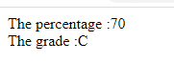

1. write a PHP program for find „Thursday‟ in week using switch Function.

<?php

$day = "4";

switch ($day) {

case "1":

echo "It is Monday!";

break;

case "2":

echo "It is Tuesday!";

break;

case "3":

echo "It is Wednesday!";

break;

case "4":

echo "It is Thursday!";

break;

case "5":

echo "It is Friday!";

break;

case "6":

echo "It is Saturday!";

break;

case "7":

echo "It is Sunday!";

break;

default:

echo "Invalid number!";

}

?>

Output:



1. Write a PHP program to check Leap years between 1901 to 2016 Using nested if.

<?php

for($year=1901; $year<=2016; $year++)

{

if($year %4==0)

echo "$year is a Leap Year.";

else

echo "$year is not a Leap Year.";

}

?>

OUTPUT:

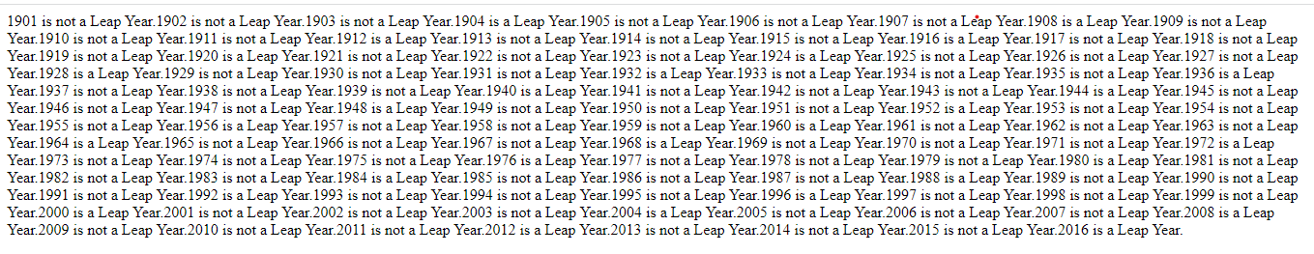

1. Write a PHP program to find the largest of three numbers using ternary Operator.

<?php

$x= 15;

$y= 20;

$z= 25;

{

$max = ($x > $y)? (($x > $z)? $x : $z) : (($y > $z)? $y : $z);

echo "Largest number among $x, $y and $z is: $max\n";

}

Output:

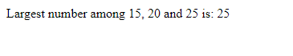

1. Write a program in PHP to print Fibonacci series. 0, 1, 1, 2, 3, 5, 8, 13, 21,

34

<?php

$num = 0;

$n1 = 0;

$n2 = 1;

echo "Fibonacci series for first 10 numbers:";

echo $n1.' '.$n2.' ';

while ($num < 8 )

{

$n3 = $n2 + $n1;

echo $n3.' ';

$n1 = $n2;

$n2 = $n3;

$num = $num + 1;

}

?>

Output:



1. Write a program to find whether a number is Armstrong or not

**<?php**

**$a=$i=1634;**

**$p=strlen($i);**

**$sum=0;**

**while($i>0)**

**{**

**$b=$i%10;**

**$sum=$sum + pow($b,$p);**

**$i=$i/10;**

**}**

**if($sum==$b){**

**echo "$a is an Armstrong number <br>";**

**}**

**else**

**{**

**echo "$a is not an Armstrong number <br>";**

**}**

**?>**

Output:-

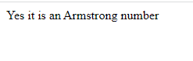

1. Write a program to print the below format :

5 9

2610

3711

4812

<?php

for($i=1; $i<=4; $i++)

{

$b=$i;

for ($j=0; $j<=2; $j++)

{

echo "$b";

$b= $b+4;

}

echo"<br>";

}

?>

Output:-

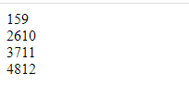

1. Write a program for this Pattern:

*****

*

*

*

*****

<?php

for($i=1; $i<=5; $i++)

{

for($j=1; $j<=5; $j++)

{

if($i==1||$i==5||$j==1)

{

echo "*";

}

}

echo "<br>";

}

?>

Output:-

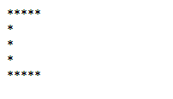

1. What will be the values of $a and $b after the code below is executed? Explain your answer.

$a = '1';

$b = &$a;

$b = "2$b";

$a = '1'; // $a is a variable type of string with the value '1';

$b = &$a; // $b is the reference of the $a variable.

$b = "2$b"; // $b & $a have for value the string '2' concatenate with the value of the variable $a (string '1').

So the output of value a and b is 21.

1. How can you tell if a number is even or odd without using any Condition or loop?

<?php

$arr=array("0"=>"Even","1"=>"Odd");

$check=13;

echo "Your number is: ".$arr[$check%2];

?>

Output:



1. How can you declare the array (all type) in PHP? Explain with example Covert a JSON string to array.
2. Write program to remove duplicate values from array

-> array_unique function. This function will remove the duplicate values from the array.

Syntax:

array array_unique($array, $sort_flags)

<?php

$a = array("red", "green", "pink", "blue");

print_r(array_unique($a));

?>

Output:-

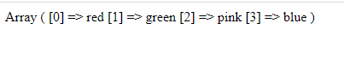

(13) Get random values from array

-> There are two functions to get random value out of an array in PHP. The shuffle() and array_rand() function is used to get random value out of an array.

Php array_rand: The array_rand() function is an inbuilt function in PHP which is used to fetch a random number of elements from an array. The element is a key and can return one or more than one key.

Syntax: array_rand( $array, $num )

This function accepts two parameters $array and $num. The $array variable store the array elements and $num parameter holds the number of elements need to fetch. By default value of this parameter is 1.

<?php

$arr = array( "a"=>"21", "b"=>"31", "c"=>"7", "d"=>"20" );

$key = array_rand($arr);

echo $arr[$key];

?>

(14) Write a PHP script which decodes the following JSON string

-> The json_decode() function is used to decode or convert a JSON object to a PHP object.

Syntax:

json_decode(string, assoc, depth, options)

<?php

$jsonobj = '{"Peter":35,"Ben":37,"Joe":43}';

var_dump(json_decode($jsonobj, true));

?>

Output:-

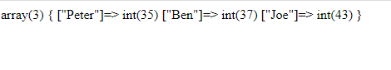

(15) Use a for loop to total the contents of an integer array called numbers which has five elements. Store the result in an integer called total.

<?php

$arr =array(12, 3, 4, 15, 10);

$n = sizeof($arr);

$sum=0;

for ($i = 0; $i < $n; $i++)

{

$sum = $sum + $arr[$i];

}

echo "Sum of given array is " . $sum;

?>

Output:-



(16) Declare a Multi Dimensioned array of floats called balances having

Three rows and five columns.

-> <?php

$cars = array (

  array("Volvo",22, 18,'v', 18.5),

  array("BMW",15,13, 'b' , 16.5),

   array("Saab",5,2,'s',10.2 ),

);

for ($row = 0; $row < 3; $row++) {

   echo "<p><b>Row number $row</b></p>";

   echo "<ul>";

  for ($col = 0; $col < 5; $col++) {

     echo "<li>".$cars[$row][$col]."</li>";

   }

   echo "</ul>";

}

?>

Output:

